Part 1: Find your IP Address
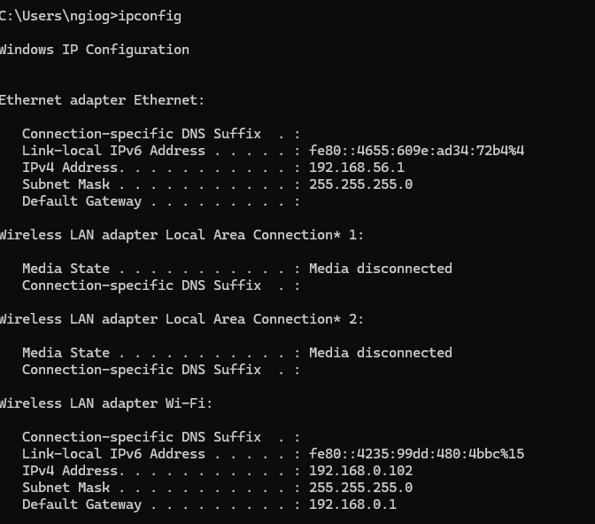
My IP Address is 192.168.0.102

Part 2: Test network Connectivity.
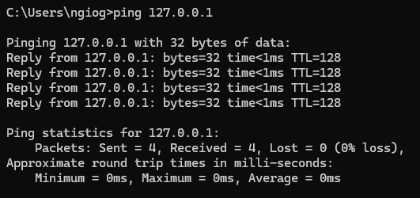
My network connectivity is okay as I have zero packet loss.
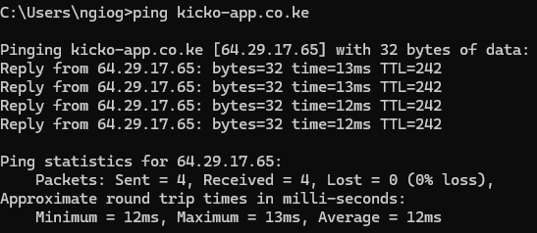
Pinged my own website to see the connectivity, zero packet loss.

- IP Addresses in security context
  - Asset Identification and Mapping.
  - Incident analysis and response – In any incident that happens over the internet, the first point of contact is the IP Address.
  - Network Access control – IP is the base firewall for any network.
- Ping Commands
  - Asset Discovery – Ping can locate all the appliances in the house.

